Georgia State Parks and Historic Sites
Memorial Day Holiday Weekend Summary
05.26.2020

Crowds:
- Some sites visitation was slower than previous weekends. However, a number of sites continued to have high visitation requiring day use access to be limited including: Amicalola Falls, Black Rock, Cloudland Canyon, Ft. Yargo, High Falls, Mistletoe, Providence, Red Top, Sweetwater, Tallulah Gorge, Vogel and Wormsloe. Several beaches had to restrict access due to being at capacity including Don Carter, Ft. Yargo and Mistletoe. Boat ramps at Florence Marina, Ft. McAllister and Mistletoe reached capacity.
- Arrowhead, The Creek, and Highland Walk experienced increased play at all three courses compared to 2019 Memorial Day Weekend.

Memorial Day Holiday Specific Details:
- Cottage and camping occupancy was high at many sites. Day use crowds varied, some with high levels of visitation and others reporting lower visitation compared to the previous weekends. Monday’s day use visitation was limited by the threat of rain.
- A successful overnight rescue occurred at Tallulah Gorge that involved park staff, Habersham high angle ropes team and LED. In this incident several youths were trespassing and got stranded on rocks in the gorge. There was one minor injury and several citations were issued by LED.
- Laura Walker assisted hikers who left the trail Friday night and called for assistance. On Saturday night the manager had to assist a camper locked in a comfort station bathroom when the lock jammed.
- Washington State Parks Director Don Hoch visited Laura Walker on Monday.
- There were two search and rescues at High Falls ending in locating all parties safely. Visitors trespassing onto the rocks at High Falls along the Falls Trail continues to be an issue. Management is working with LED to step up patrols in this area.
- Richard B. Russell’s newly remodeled cabins 1, 2, and 3 were in service for the holiday weekend.
- Fort Yargo staff worked with LED and local responders on a brief search for an autistic male subject and a puppy left in a vehicle. Both situations found the subject and the dog in good health.

Staffing issues:
- As of today, the Division has 68 part-time and full-time staff out due to COVID-19 related reasons. A total of 42 Camp Host Units (approximately 84 people) have left due to COVID-19 and 37 units have been replaced.
- To date, two employees have tested positive for COVID-19. A Part-time employee at Wormsloe is out on quarantine after being around a family member that tested positive Friday. One part-time employee at Reed Bingham is self-quarantined due to having contact with someone COVID positive.
- Region and Headquarters Staff worked in the Field again this weekend to assist busy sites. Staff sharing is still needed and very helpful, especially at sites with high visitation and with staffing challenges.

Positives
- The new radios being placed at parks has proved to be beneficial and vital to park operations especially with traffic and parking control during busy weekends.
- The eRanger video series continues to be a huge success and went over 1 million views this past week! A new video featuring Park Rangers from the mountains to the coast, “Know Before You Go” was released just in time for the holiday weekend. Part of the video was featured on WSB-TV channel 2 this weekend. Website statistics continue to be very high including the Alerts page that had 40k views this past week, while total pageviews were up 112% YoY at 2.2 million this week, and the reservations pageviews were up 75% YoY.
- There were several minor issues over the weekend holiday, but no major problems. Staff sharing continues to save the day at several of the most busy sites.
- Fort King George created a new self-guided tour map specifically for children.
- LED continues to be supportive in assisting with enforcing the Governor’s Executive Order, SAR, and crowd control.
- To assist with the crowds at Sweetwater, LED had officers from South Georgia at the entrances over the weekend. This was helpful with the management of capacity limits. Douglas County installed “No Parking” signs along Mt. Vernon Rd. outside of Sweetwater Creek. These signs discouraged roadside parking.

Challenges
- There is a water quality advisory in place at Fort Mountain beach area. Additional water testing is in progress.
- Several temporary staffing challenges are requiring adjustments to site work schedules and sharing staff from other sites.
- Don Carter, James H. Floyd, and Gordonia operated this weekend without a manager and Fort McAllister without an assistant manager.
- Crowd control on the falls at High Falls was a challenge this weekend. There were also two SAR at High Falls. Monroe County SO and DNR LED assisted in both incidents. Drugs were involved with one of the searches.
- Fort Yargo experienced a lift station issue at the beach on Monday and had to temporarily restrict access to the bathrooms in that area.
- Fort Yargo worked with local responders and LED on the following issues this past week: an apparent drug abuse issue from a camper who was removed from the site and two guests illegally fishing on the dam’s riser.
- Black Rock and Mistletoe reported some verbal abuse due to capacity limits.
- At Elijah Clark, LED had to respond to two guests a few coves up from the park who were in an argument over loud music.
- Red Top Mountain’s Bethany Boat Ramp had issues with roadside parking and the entrance to the boat ramp was monitored Saturday, Sunday, and Monday.

Lodge/NGMA Holiday Report
- The only NGMA site to restrict entry was Amicalola Falls, which briefly closed Saturday and two times on Sunday. Total number of cars turned around was 350.
- Heavier than usual Memorial Day weekend traffic at all locations.
- All lodges were reopened for business on Thursday prior to Memorial Day weekend, all restaurants except of George T. Bagby also reopened.
- Unicoi Lodge 86% full Saturday night, with cabins and campsites 100% full
- Amicalola Falls Lodge 96% full Saturday night, with cabins 100% and campsites 92%
- Blackshear Resort 91% lodge, 90% cabins 100% camping
- Little Ocmulgee 47% lodge, 90% cabins, and 98% camping
- Bagby Lodge 67%, Cabins 100%
- One minor drunk and disorderly at GTB day-use area over the weekend.

Financial Summary
Our overall occupancy for all reservables decreased 2% this past weekend to 78%. This is the first weekend in three weeks that the overall weekend occupancy has decreased. Cottage rentals continue to return, but are still less than previous years. This past weekend we were at 87% occupancy, 8% less than last year. Camping continues to see high occupancy, reaching 90% this past weekend. This is up 2% from the same weekend last year. Yurt occupancy saw a 5% drop this past weekend to 91%.

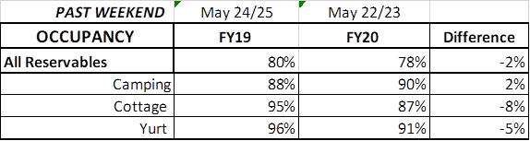
Upcoming Weekend:
For the upcoming weekend, we are seeing a 6% increase in all reservables. Camping is showing a 2% increase over last year, up to 90% occupancy. Cottages are showing a 7% increase compared to the same weekend last year. This is the first time since COVID19 started, that the upcoming weekend cottage occupancy is already indicating an increase over 2019. For this upcoming weekend, yurts are 92% booked. This is down 2% over last year.
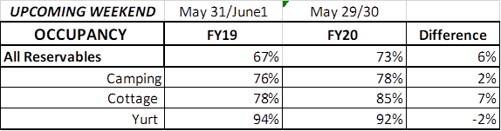
Revenue:
For the month of March through May 24th, we have seen a decrease in revenue of 1% or a loss of $81,000. This past week, May 18th – 24th, we actually saw a 59% or $504,000 increase in overall revenue. This is the sixth week in a row our revenue has increased since the COVID situation began, and the fourth week our increase was over 45%.
For overnight accommodations – camping revenue has now increased 58%, over $1.8 Million since March. This past week it increased 134% or $335,000. This is the 6th week in a row camping revenue has more than doubled. Cottages also saw a significant increase this past week, and are now showing a 4% increase during this time period; yurts are now seeing a 26% increase over last year, or $44,000.
ParkPass has now increased 6% or $67,000 during this timeframe. This past week, ParkPass revenue increased 13% or $16,000.
Golf saw its first decrease in revenue since COVID began this past week, as it dropped 16% over last year the same week. Even with this decrease, during COVID, golf revenue has increased 13% or $70,000.

The revenue continues to significantly improve over last week due to several reasons:
- In early April we changed policy from collecting only a one-night deposit when booking a reservation, to collecting all revenue at the time of booking. This is the reason for the significant increase to camping and yurt revenue , and that cottage revenue is starting to rebound. This will have an effect on future revenue collections and the amount of refunds given.
- Camping occupancy has actually improved over the previous year for the 6th weekend in a row.
- And again, the number of cancellations is starting to significantly slow down. Although we do need to keep in mind, that for future refunds, we will be refunding the revenue for the entire stay, rather than just a one-night deposit.
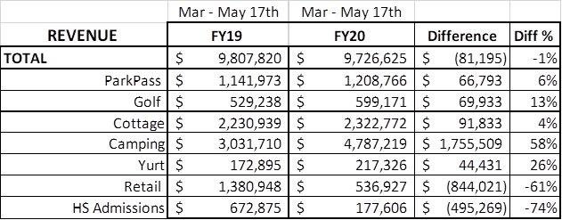

Cancellations/Refunds:
Through this morning, we have had 28,400 reservation cancellations, including $2.4 Million in actual refunds and a loss of future revenue of $10 Million. This is 1,800 more than last Monday, when we were at 26,600 cancellations. The significant drop in the number of cancellations continues, as initially we had 4,000 – 5,000 a week. Last year during the same week we had 1,000 cancellations, thus we only had 800 more cancellations this past week than last year during the same time period.
Last year during March thru YTD, we had 9,400 cancellations, including $469,000 in actual refunds and a loss of future revenue of $2.2 Million. So, total cancellations have increased over 19,000 or 202% and the amount of refunds have increased $1.9 Million.

